22BD1A052T

Connecting instance through PuTTy

Login to aws account

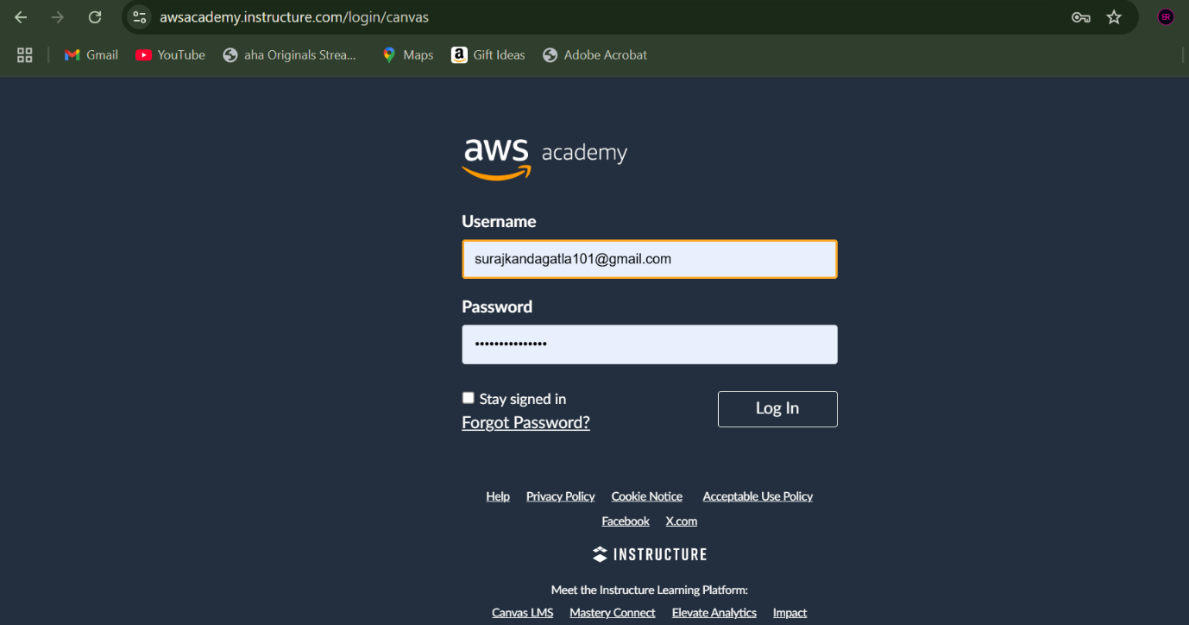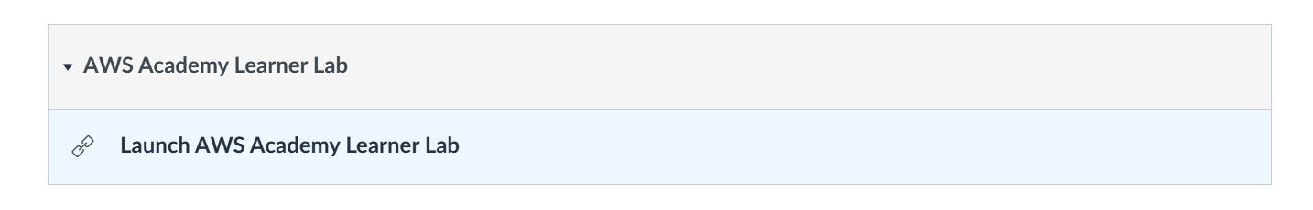

Launch a session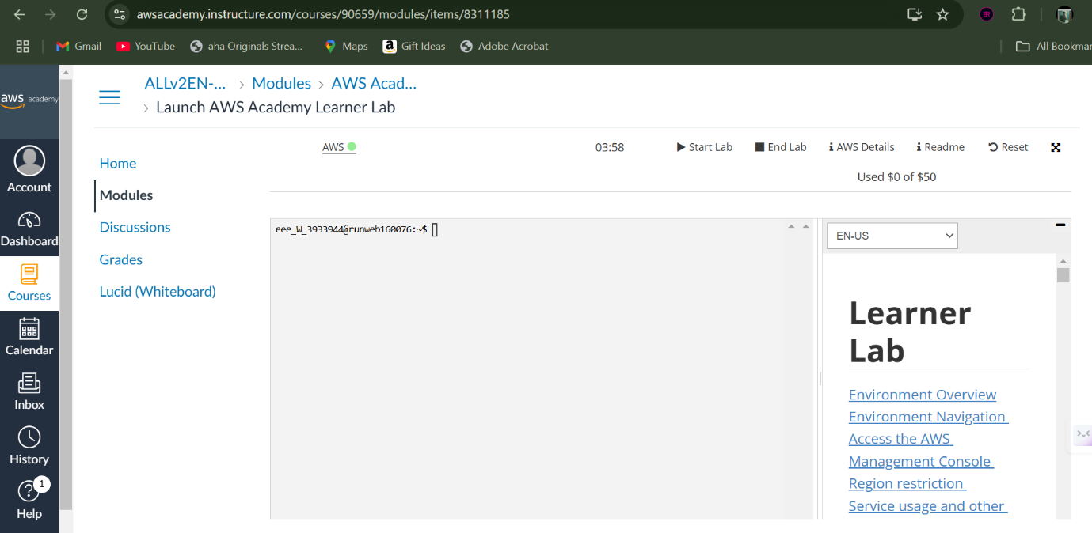

Select EC2 instance type to launch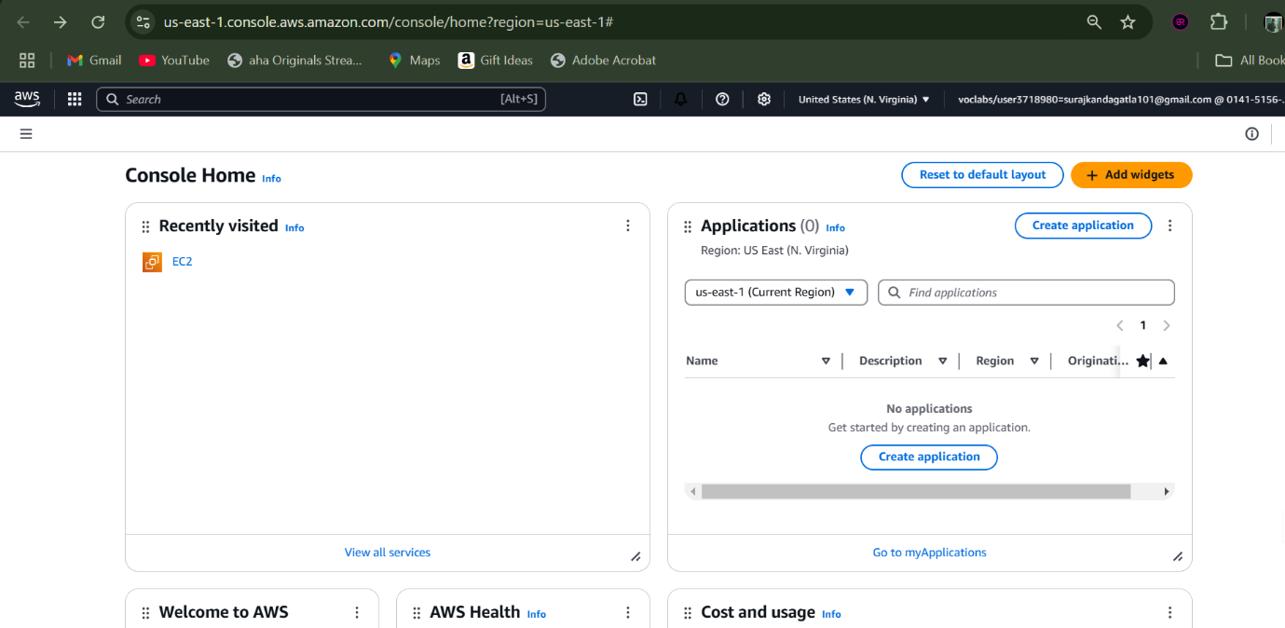

Provide a name to your instance

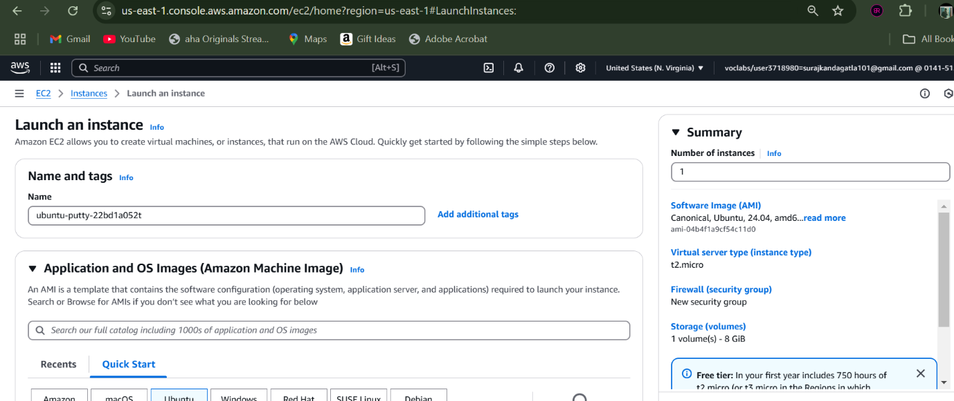

Select AMI and its version according to the use-case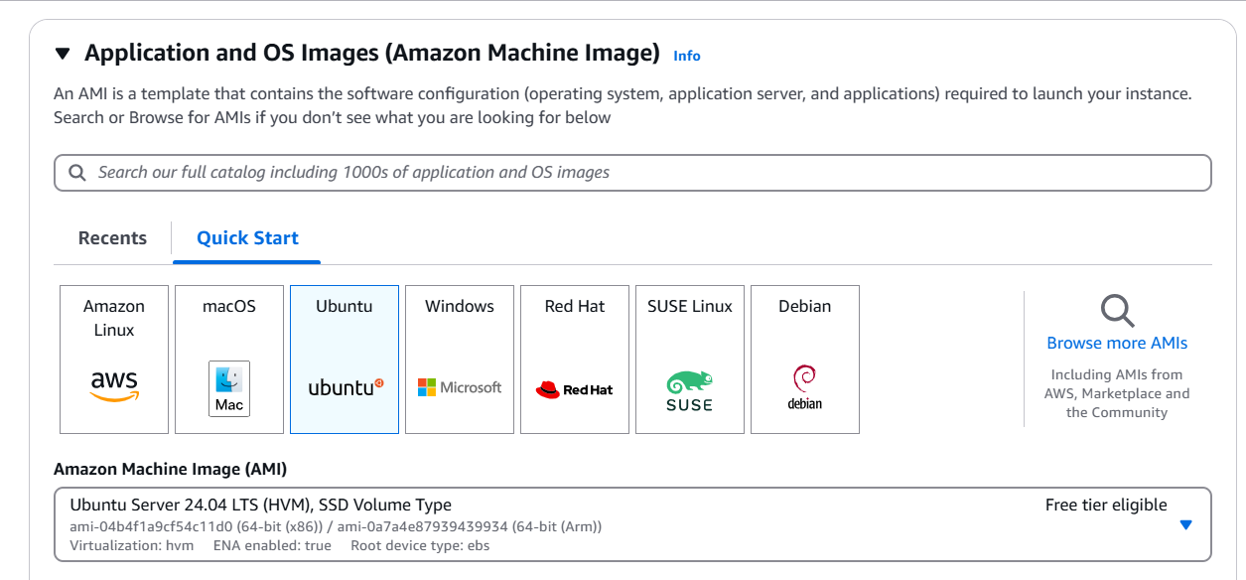

Select the architecture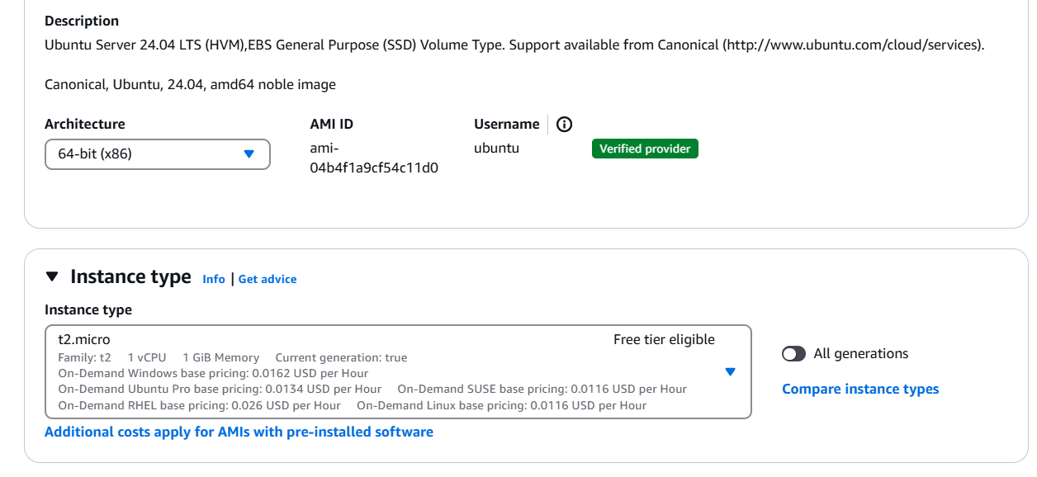

Provide a name for keypair file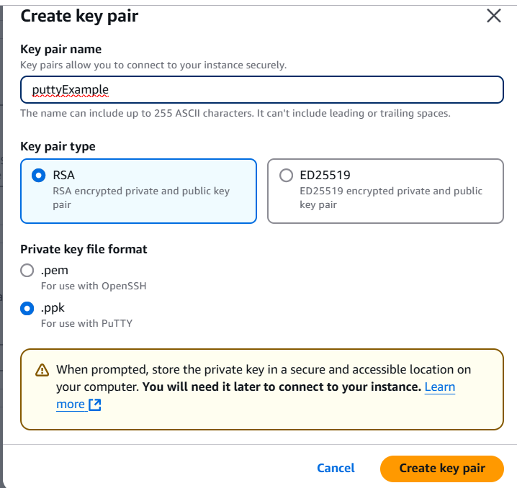

Configure the network settings for the instance.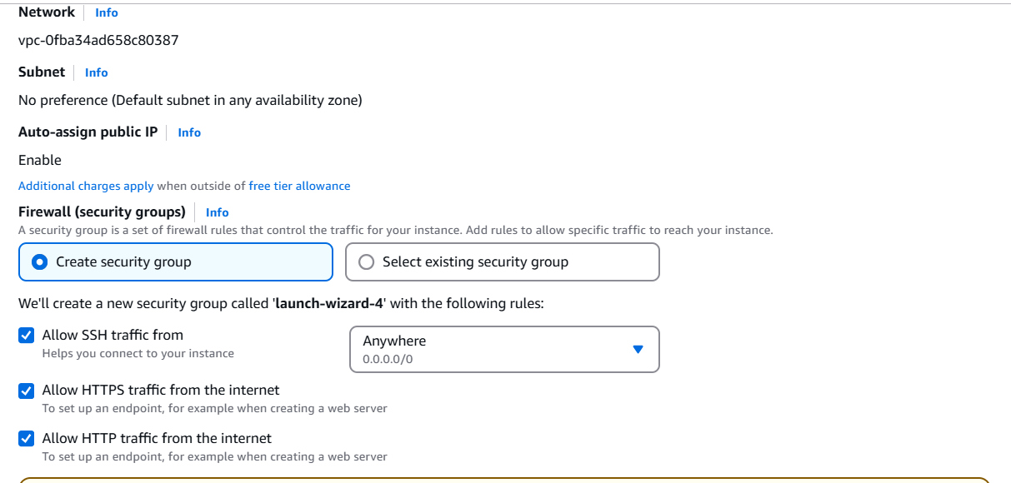

Select number of instances required and hit launch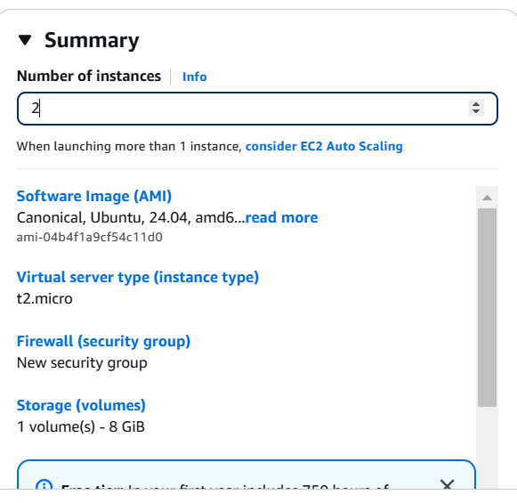

We need to download and install putty for accessing instance using .ppk file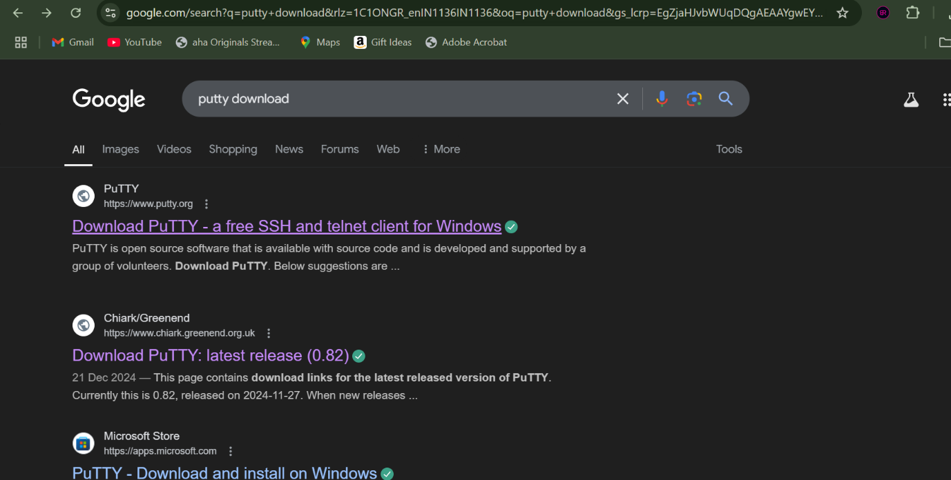

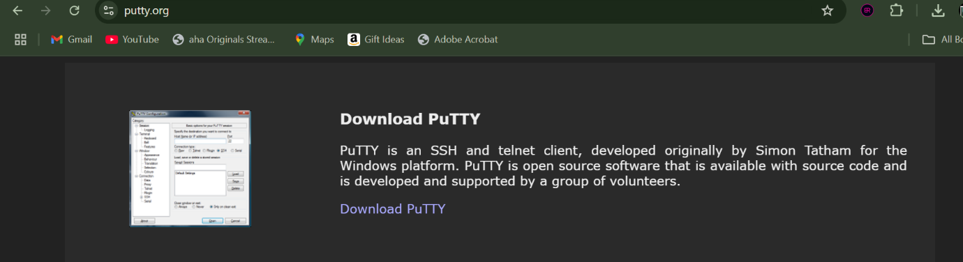

Select the .exe file according to the system architecture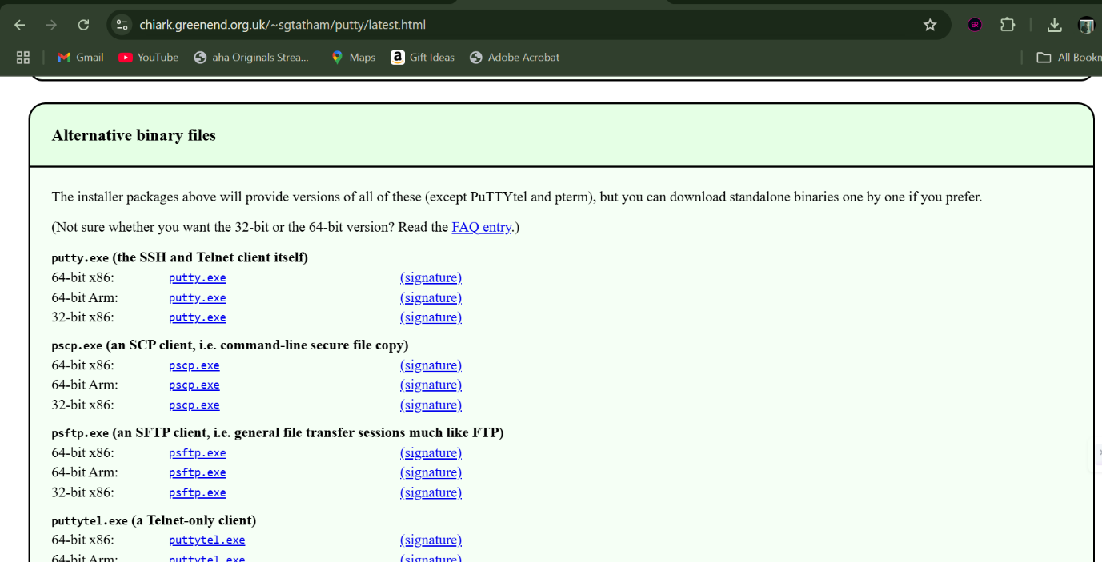

Once downloaded, install putty in your system.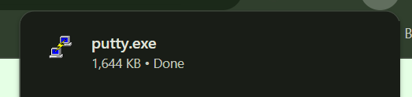

Copy the host name from SSH section.

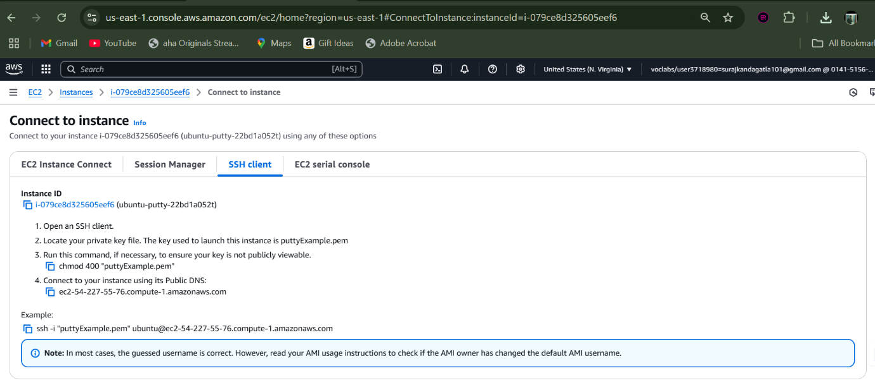

In putty paste the host name which was copied first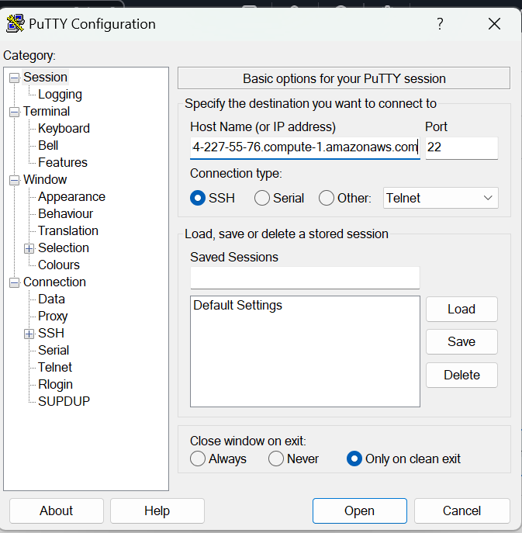

Navigate to SSH->Auth->Credentials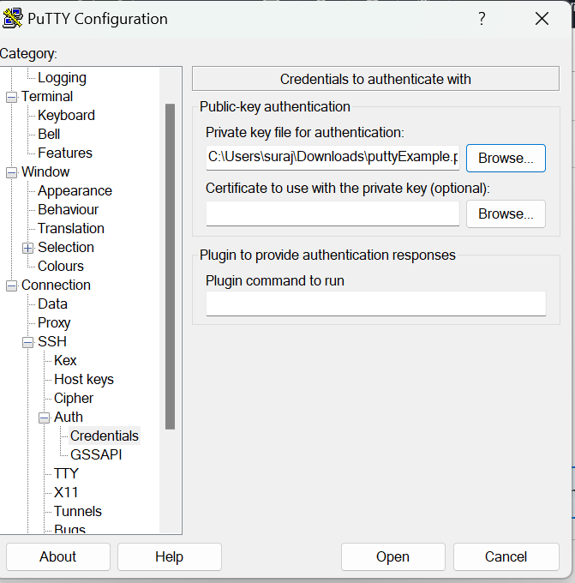

Then simply hit accept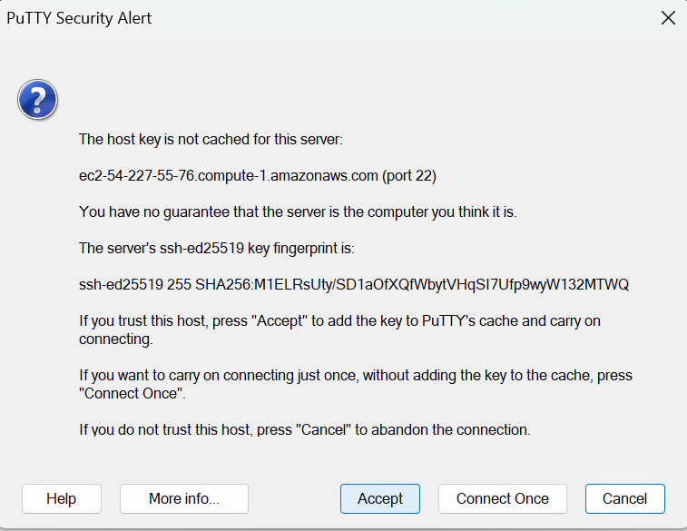

Now we are connected to our EC2 instance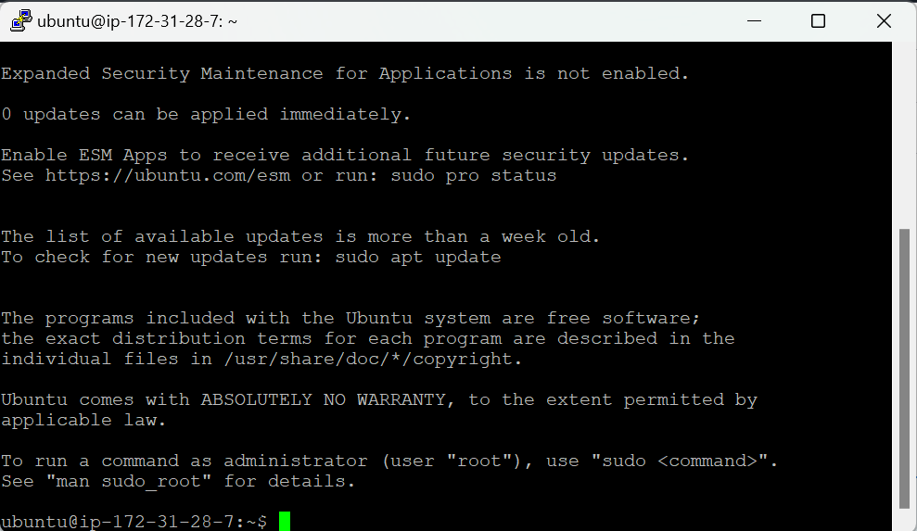

Connecting instances using EC2 direct connection

Login into aws account



Launch a session

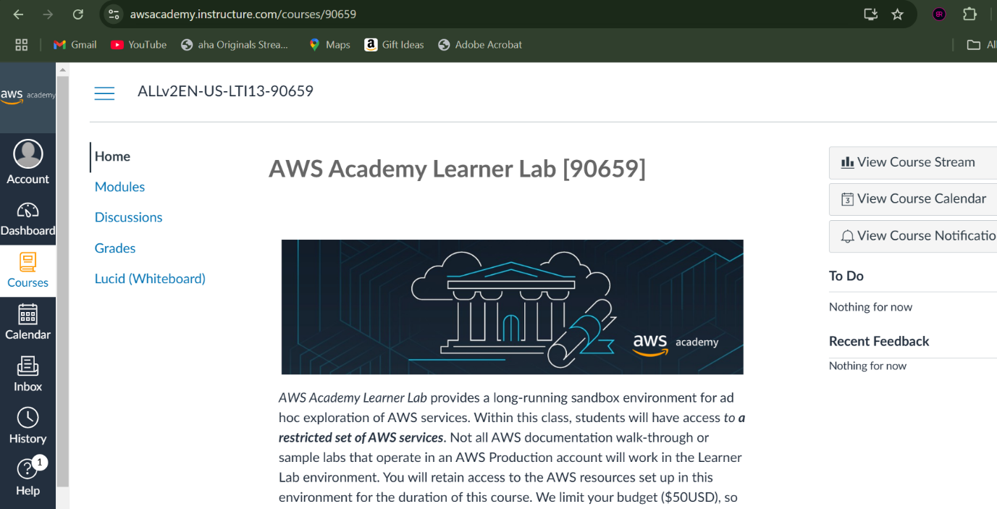



After selecting EC2 as instance type hit launch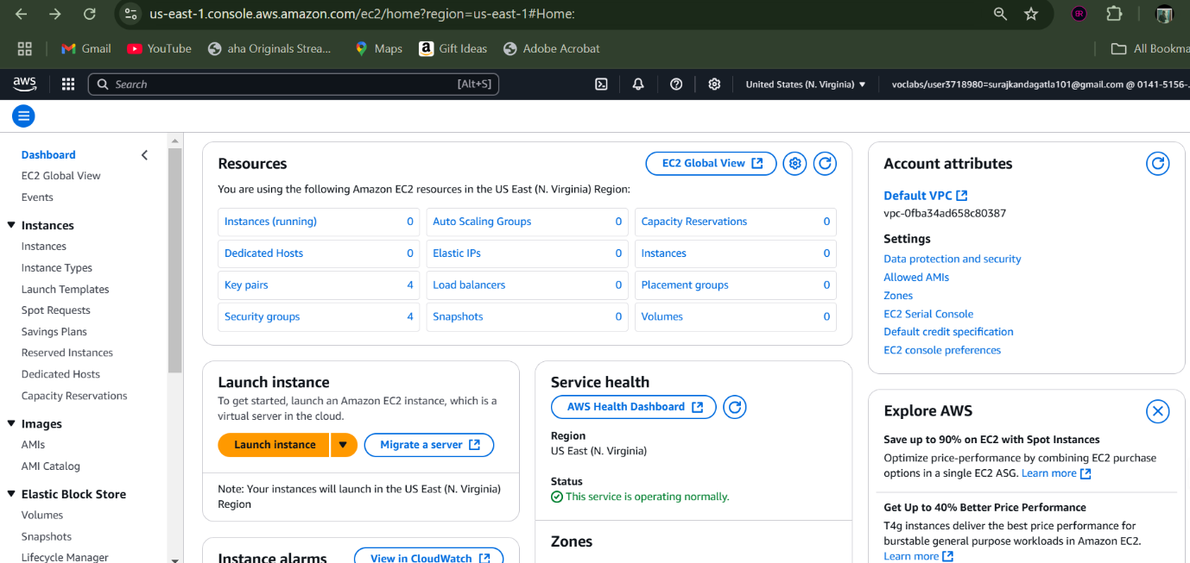

Provide a name to your instance

Select AMI according to the use-case.

Select the architecture, and the instance type as t2.micro

Provide a name for your keypair file.

Configure the network-settings 

Set the number of instances required and then simply hit launch to create instance

select the instance created and navigate to EC2 Instance Connect section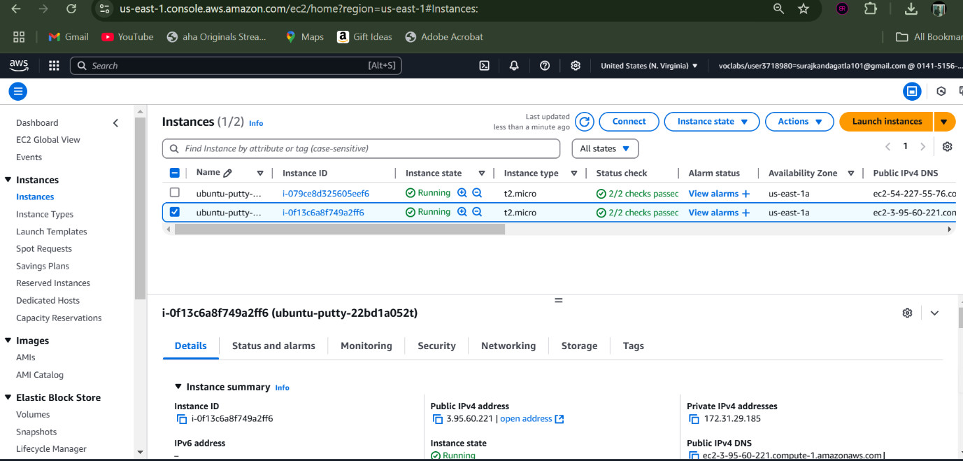

click the option called ‘connect’ to directly connect to the EC2 instance.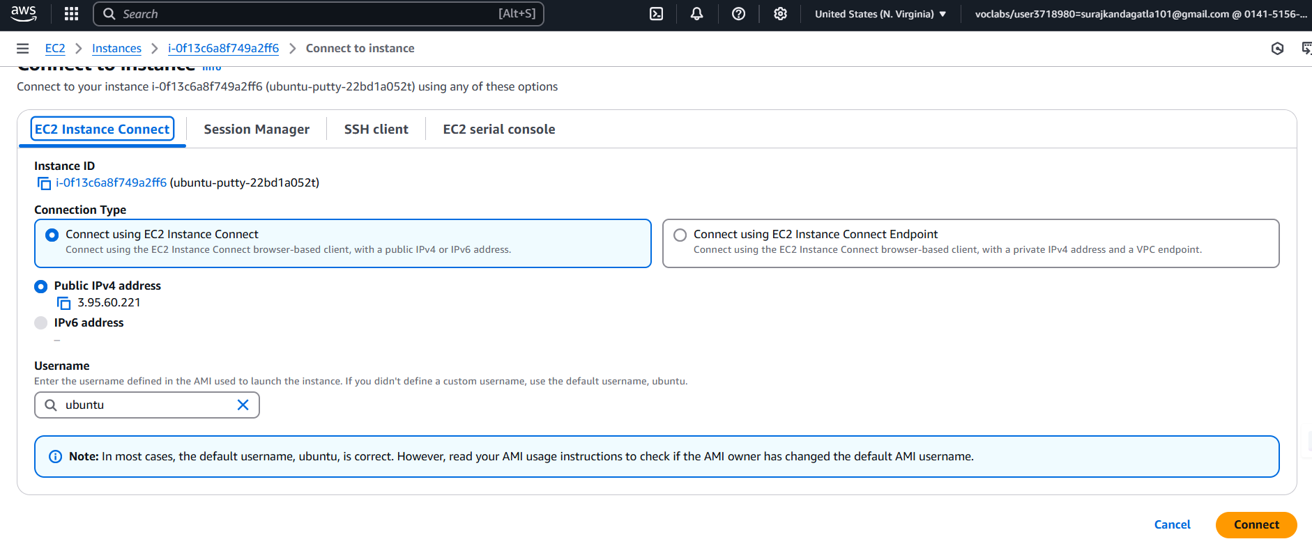

now we are finally connected to our instance.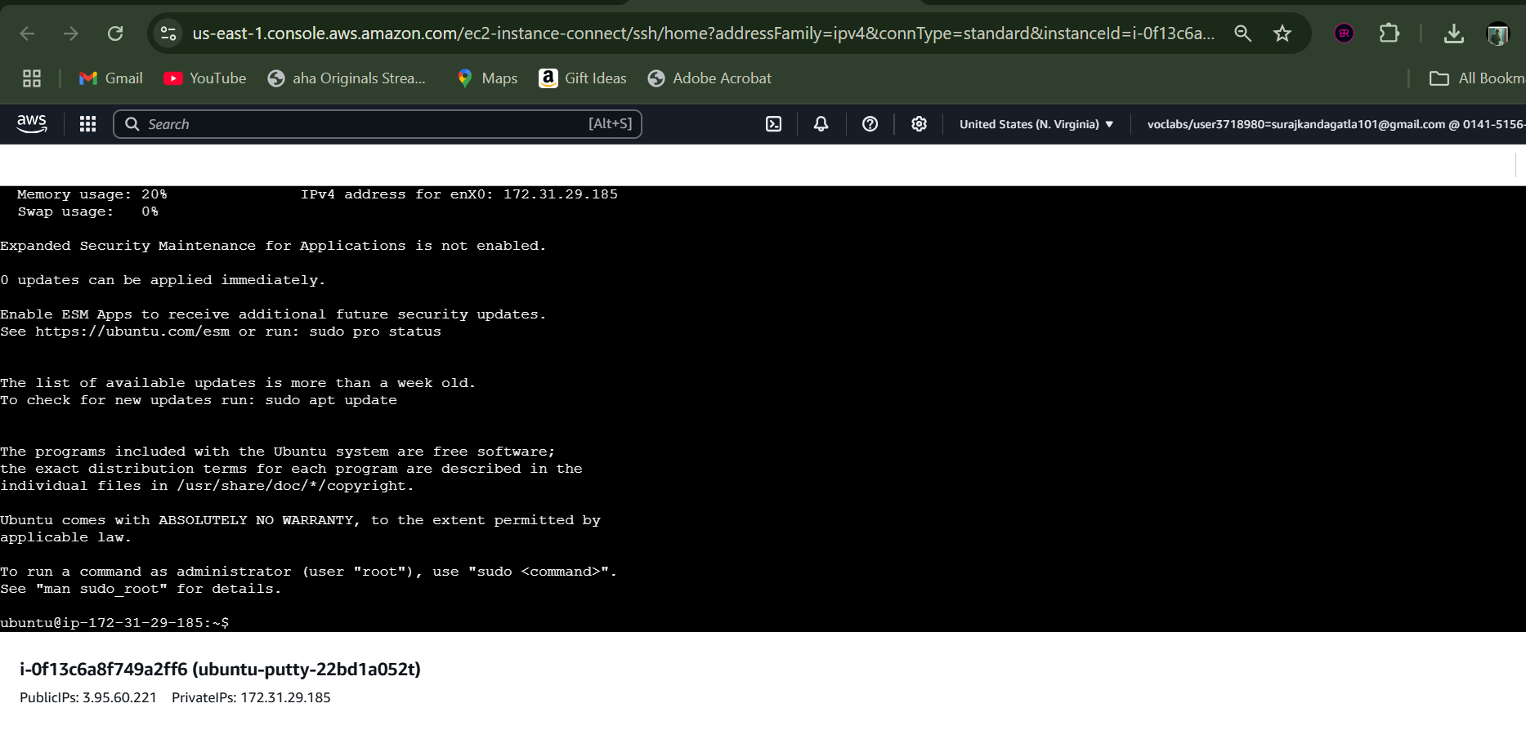

Converting pem file to ppk file

Create an instance

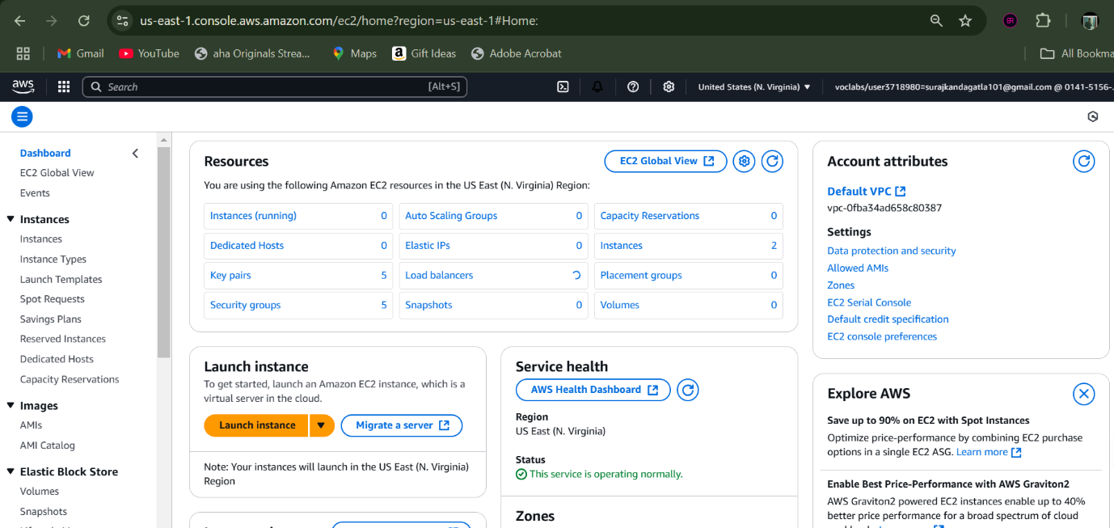

Provide a name to your instance

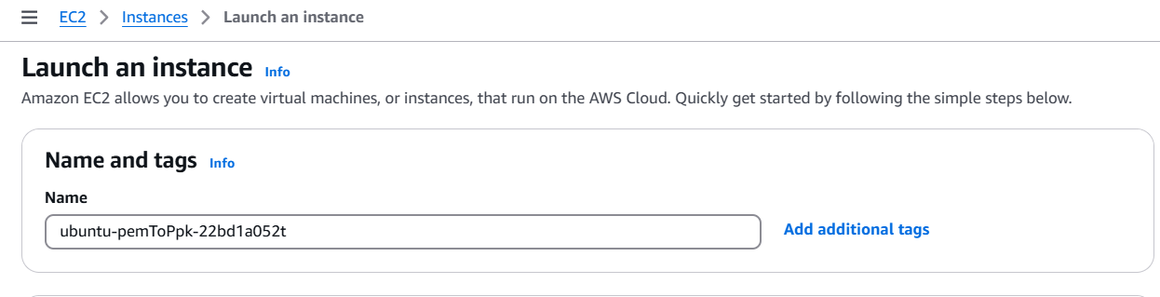

Select an AMI

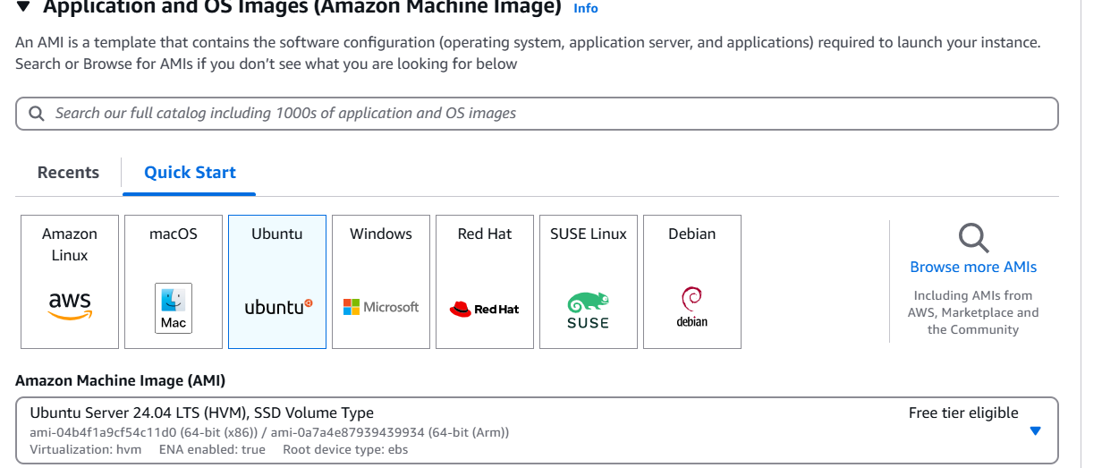

Select architecture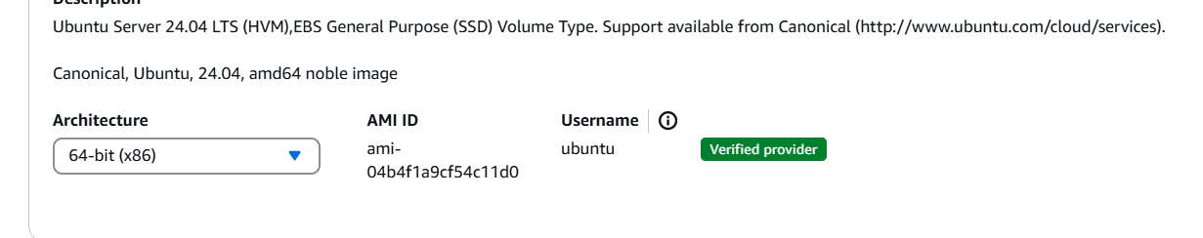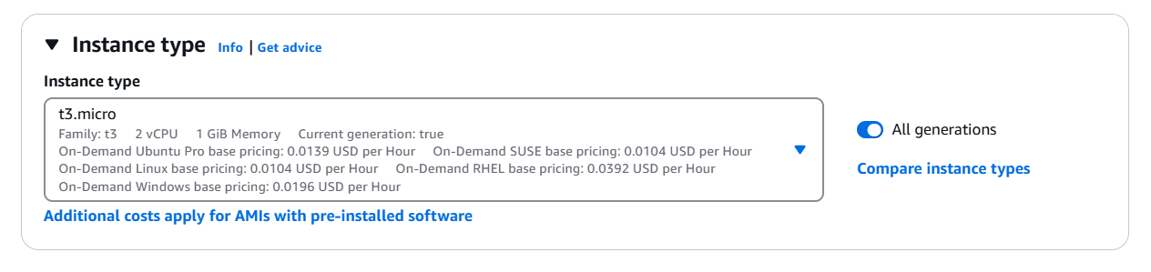

Provide a name for keypair file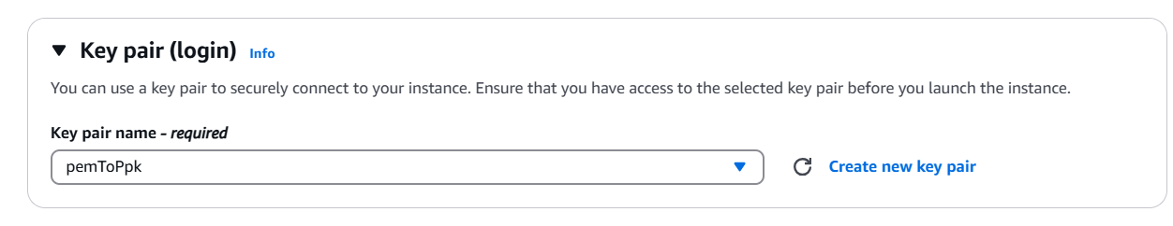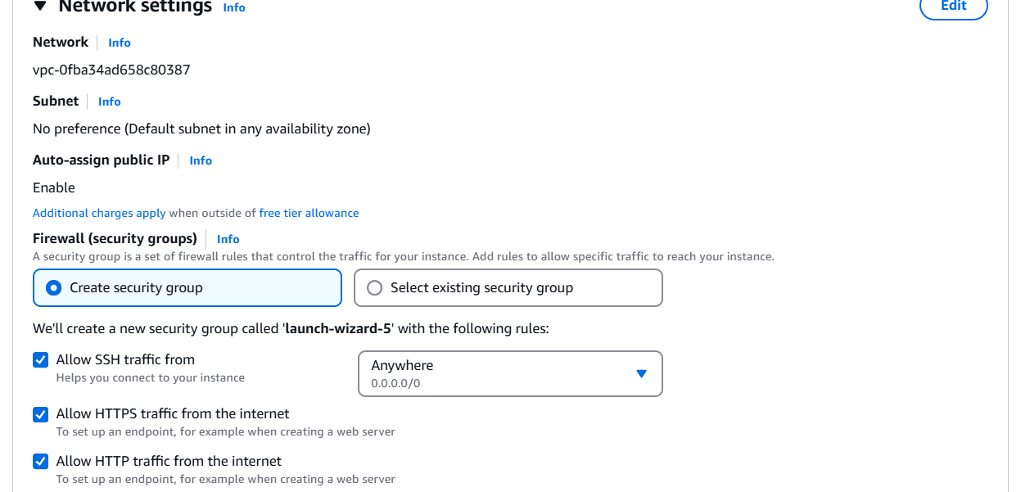

Adjust the storage accordingly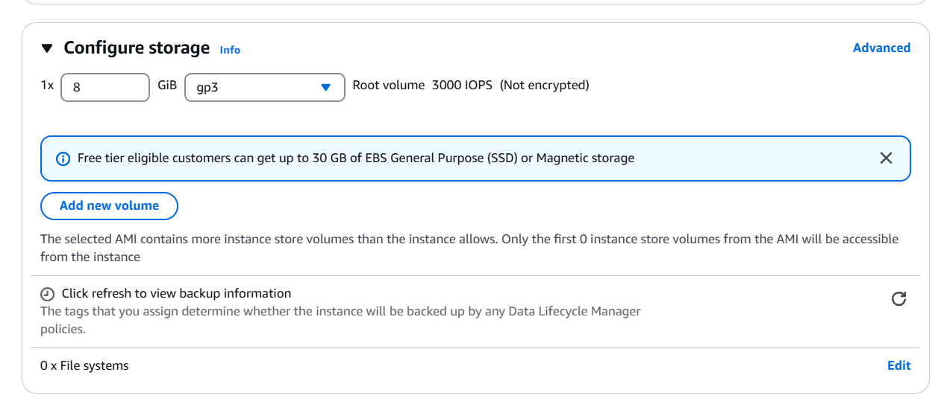provide number of instances and hit launch

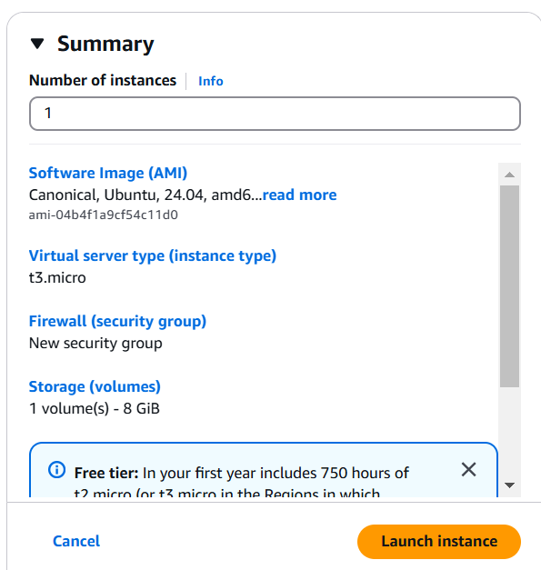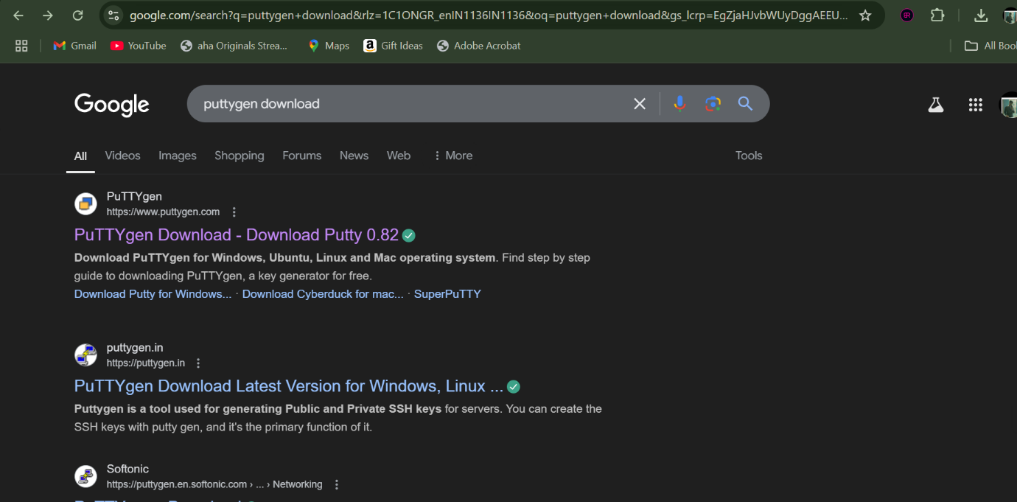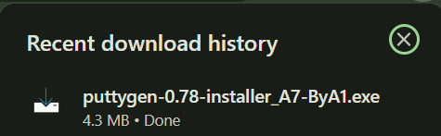

Download the puttygen installer and install it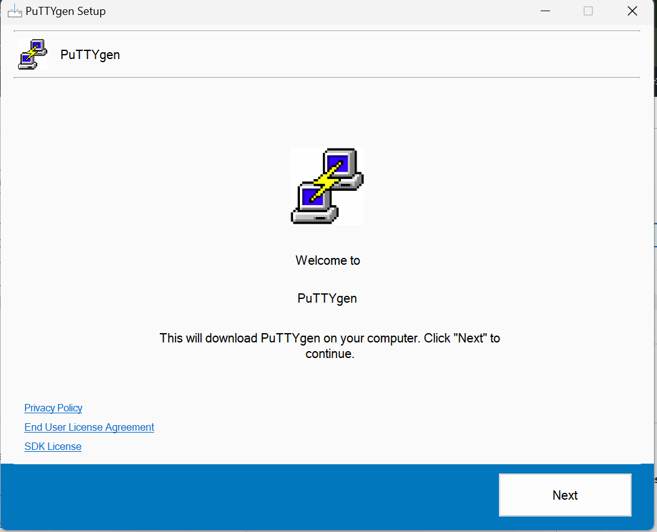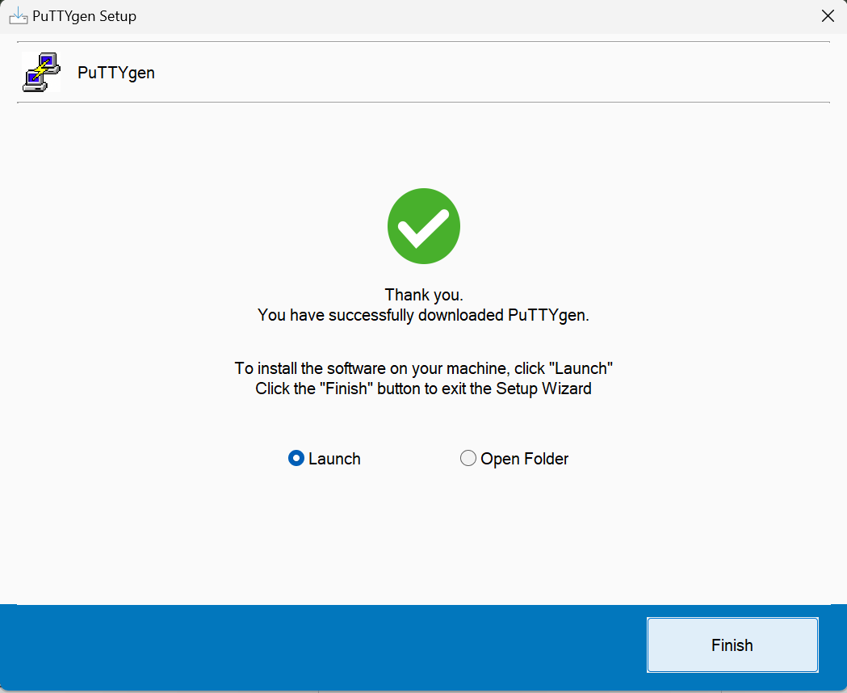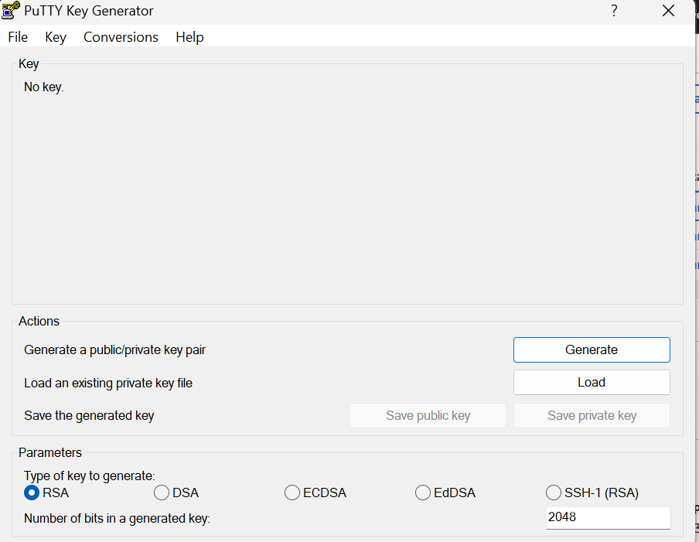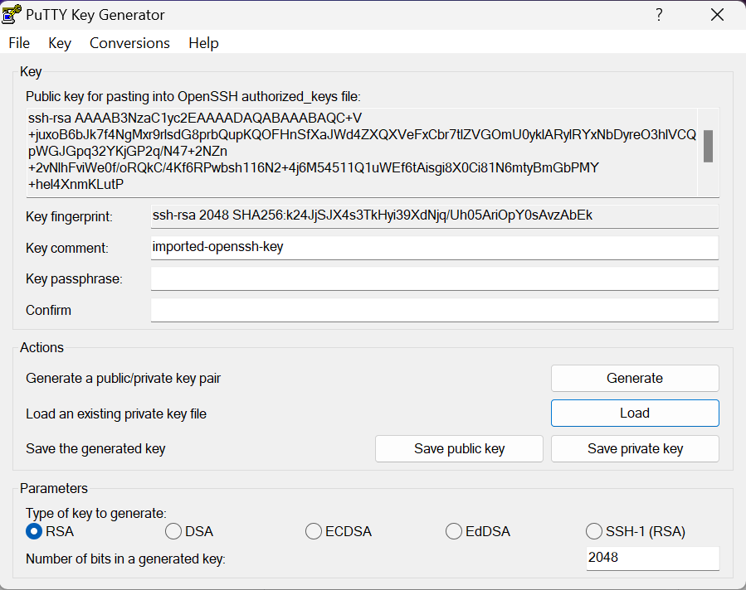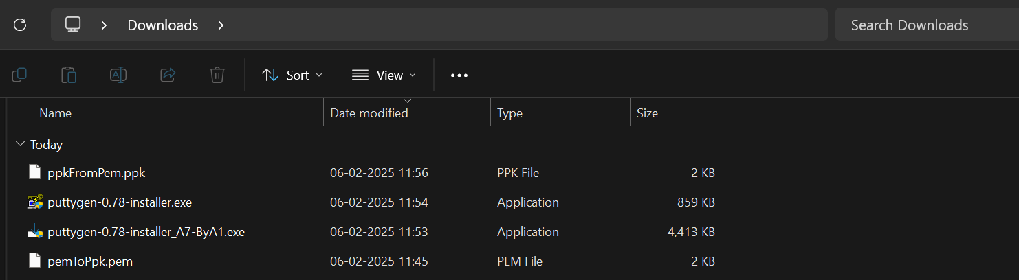

Accessing EC2 instance of Amazon_Linux AMI

Create an instance of your own naming

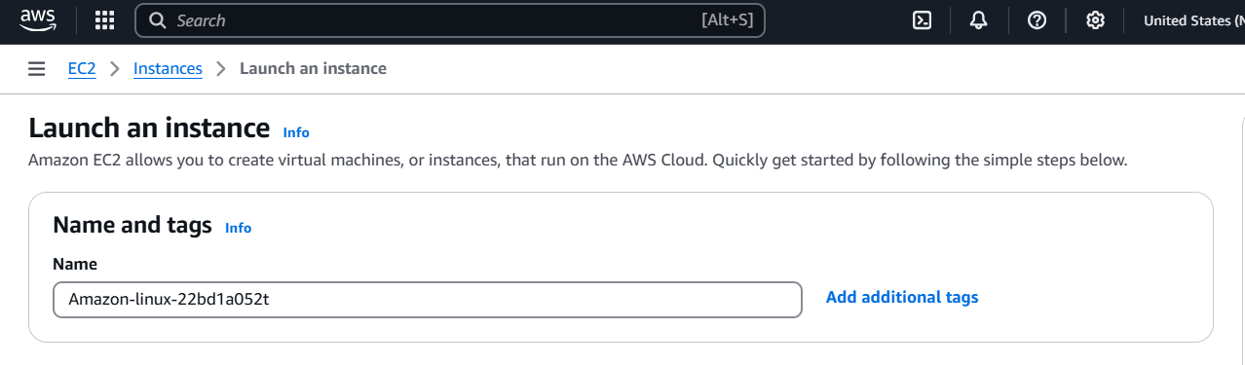

Select Amazon Linux AMI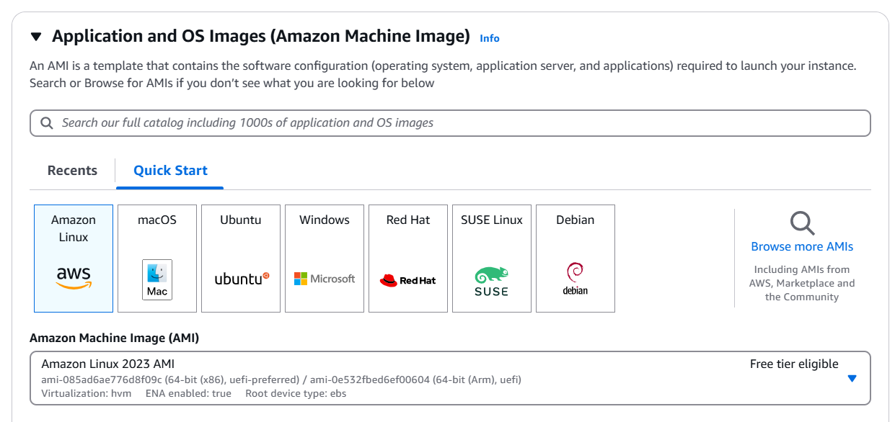

Configure the architecture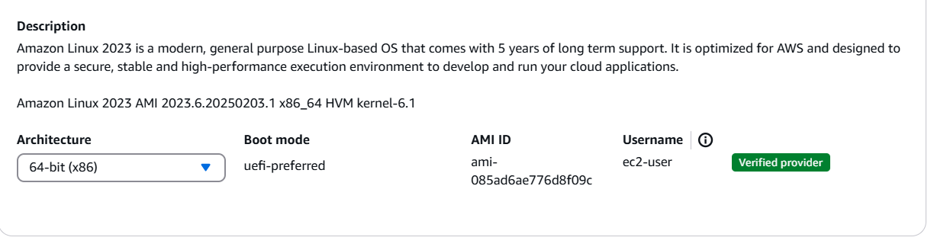

Select the instance type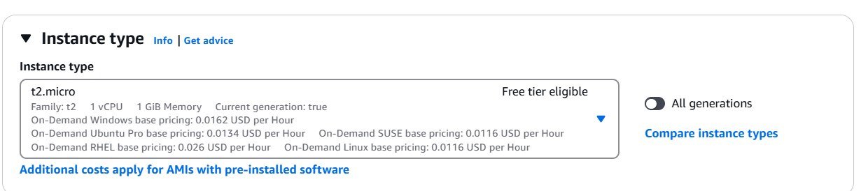

Create a keypair file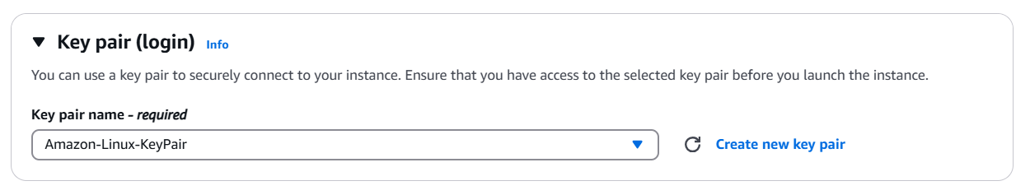

Configure the storage settings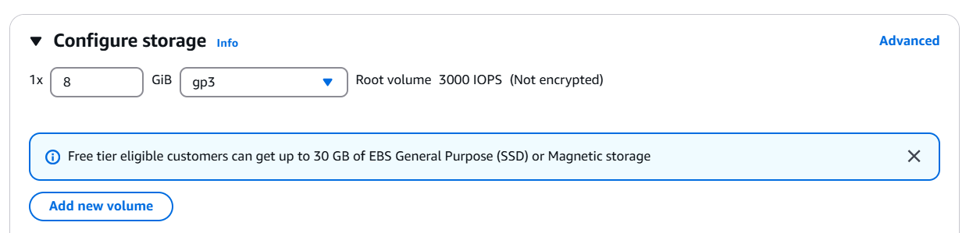

Select number of instances required and launch the instance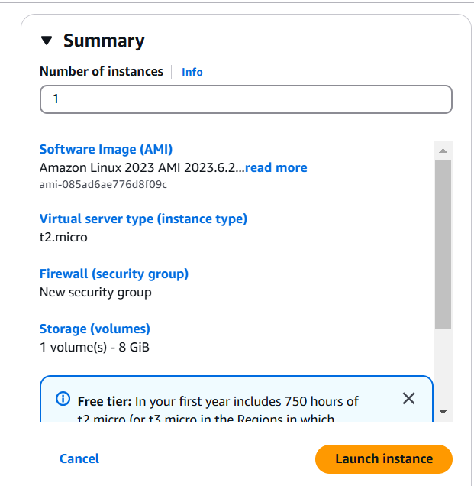

Configure the network settings

Select the instance created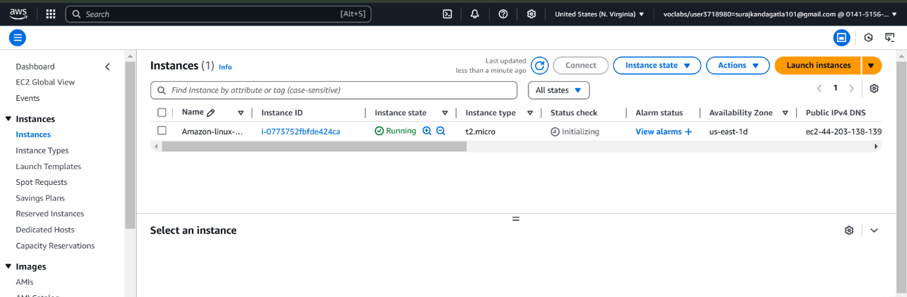

Connect the instance directly using EC2 connect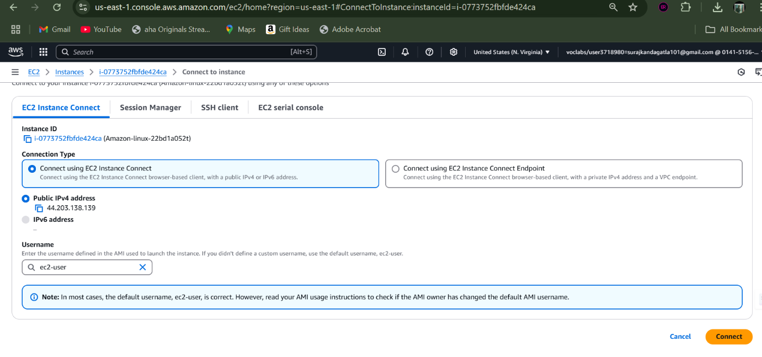

Now we are connected to the Amazon linux AMI instance

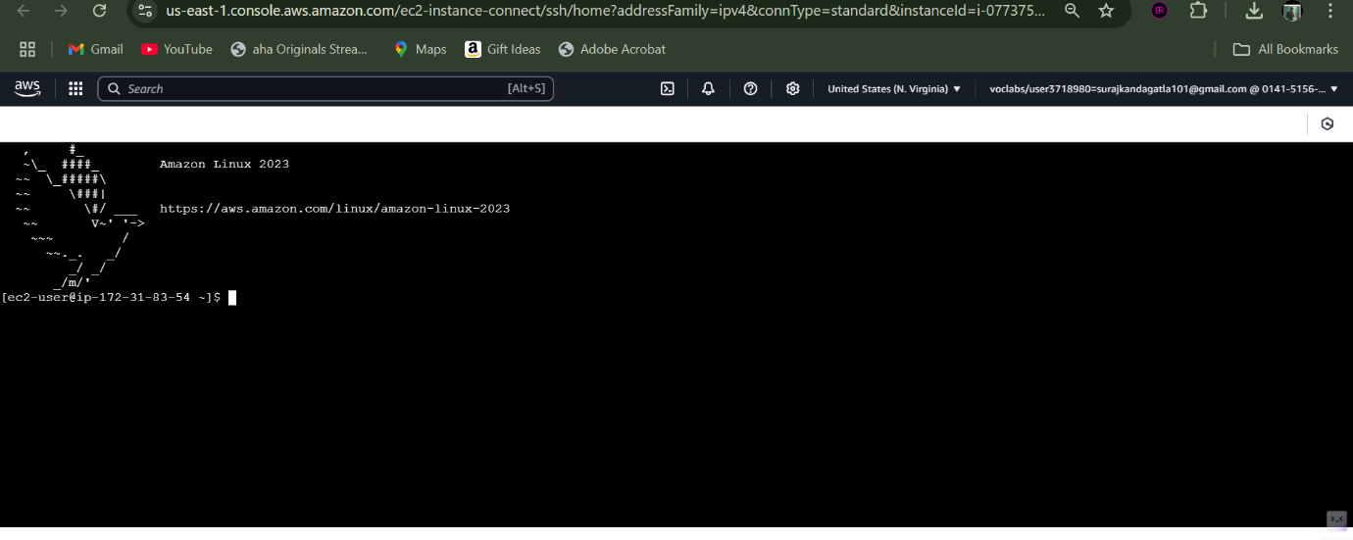

update the instance.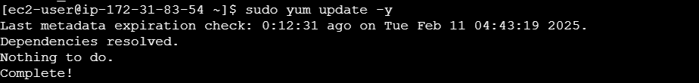

install apache using this command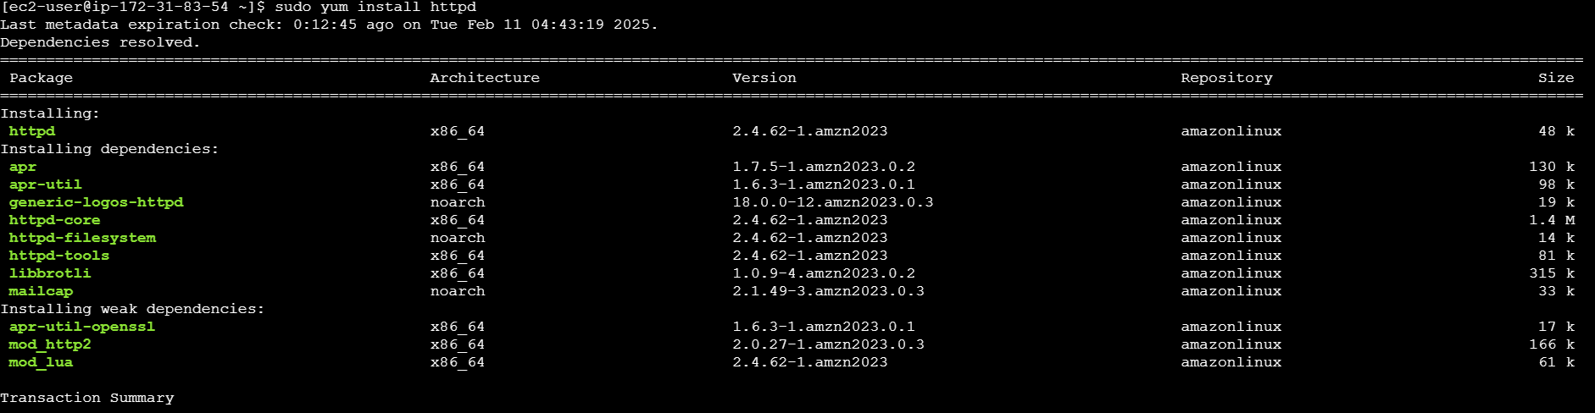

wait until the installation is done.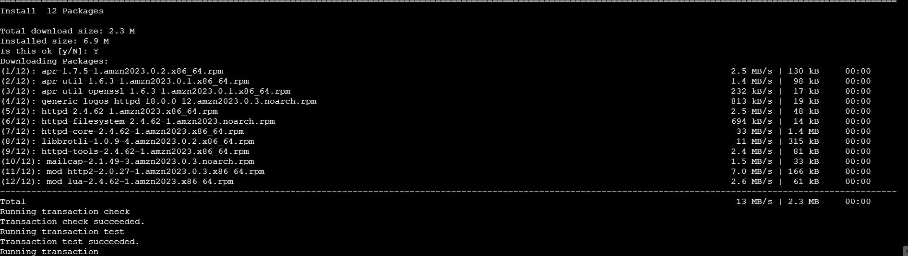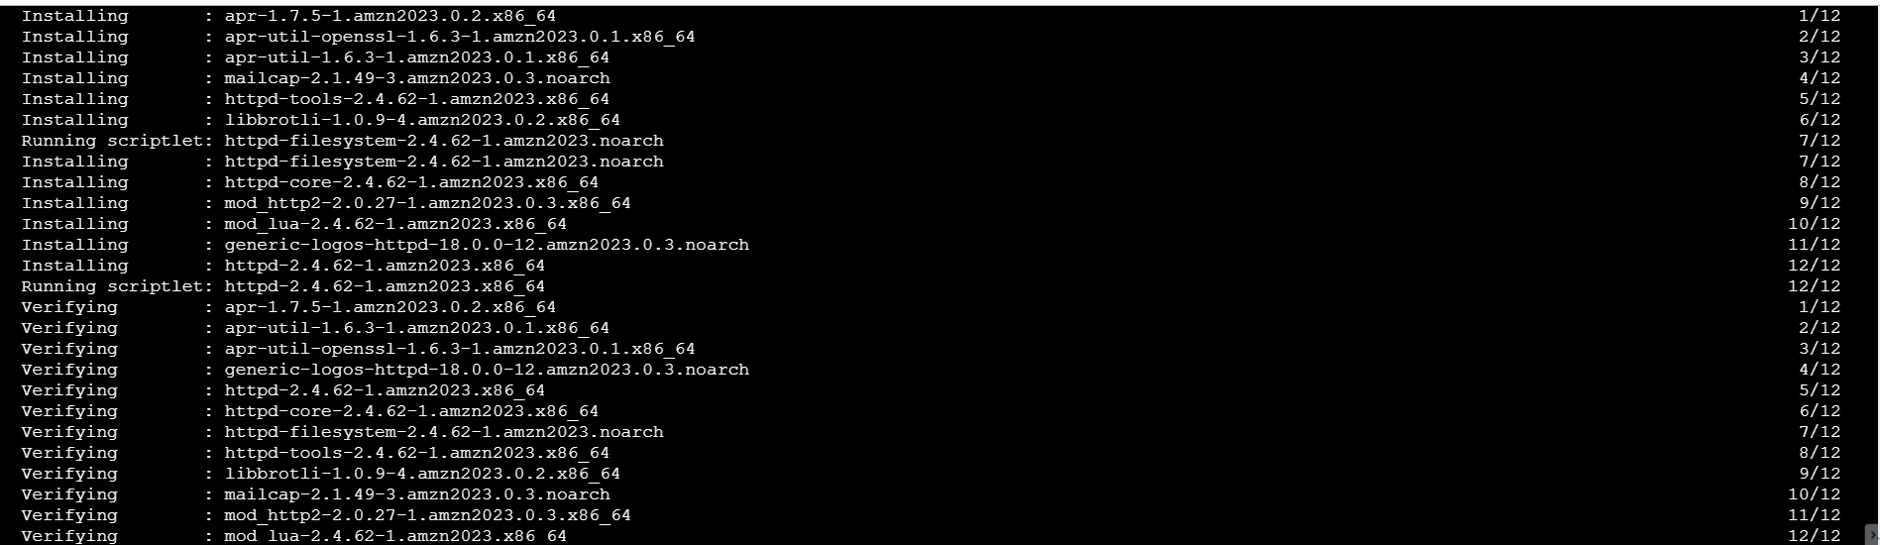

now start the apache server

check the status of the apache whether it is enabled or not.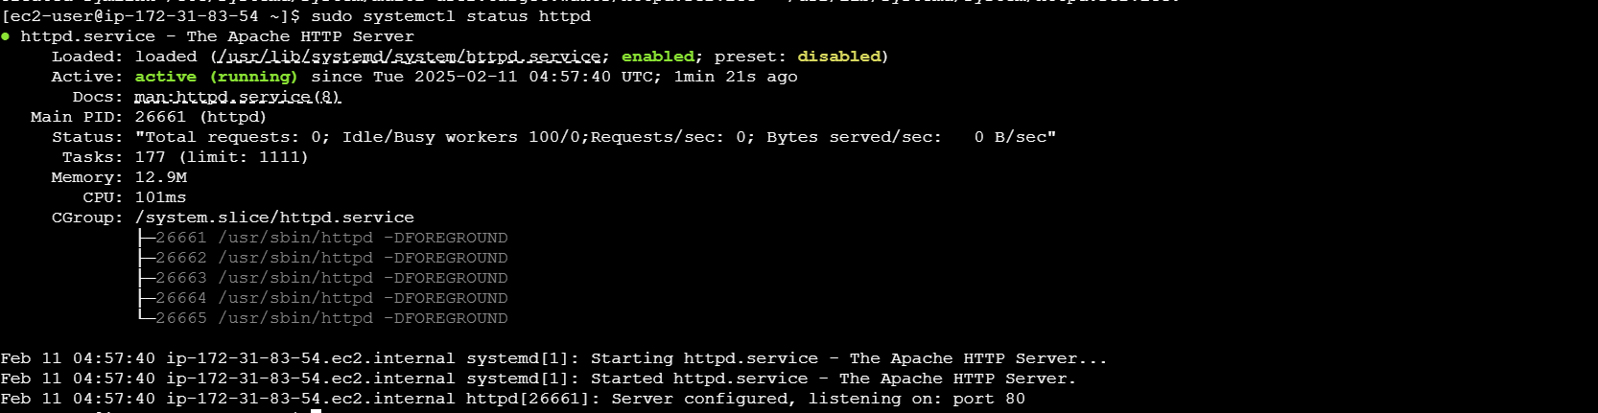

once it is enabled, access the instance using public IPv4 address.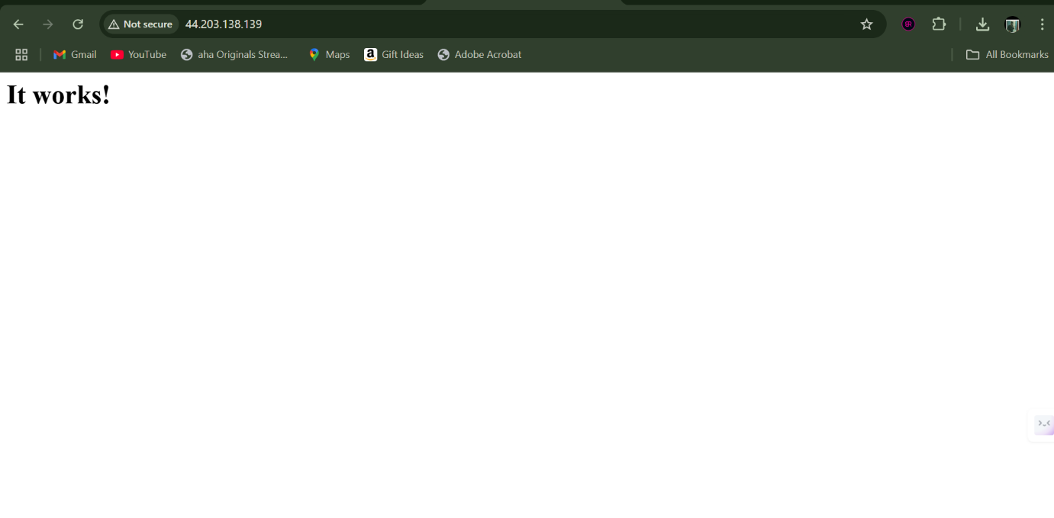

Accessing Nginx through EC2 instance.

Login into aws and create an ubuntu image

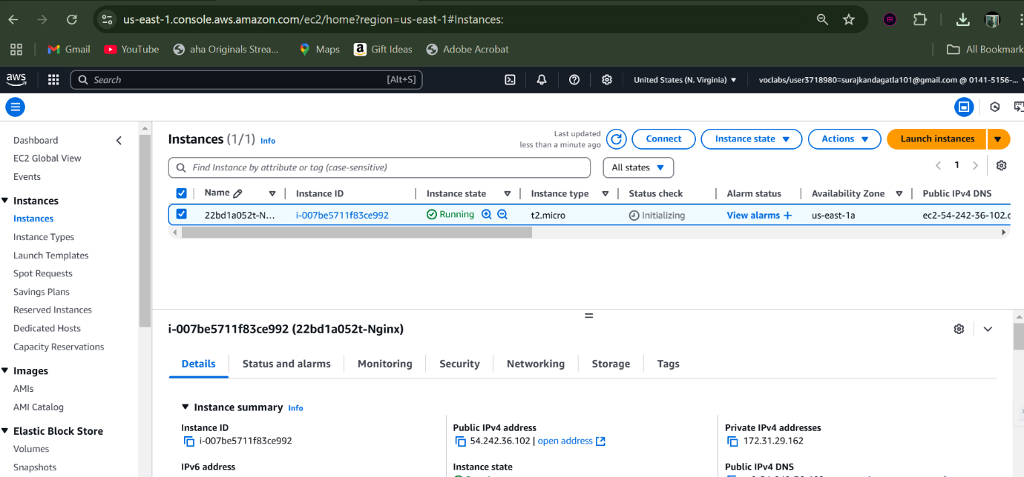

Then select the SSH client section to cop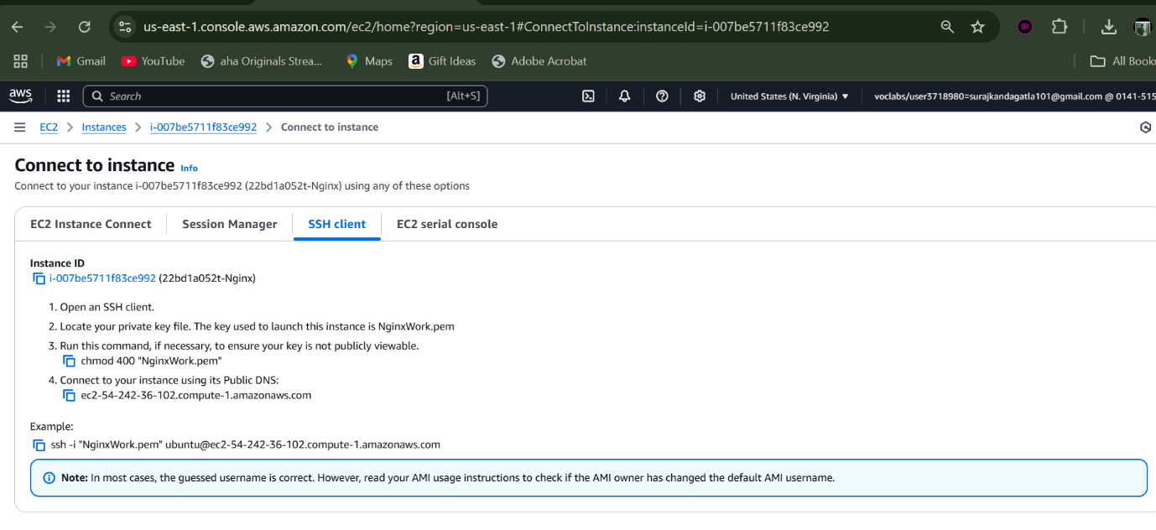

Create a folder and place your .pem file

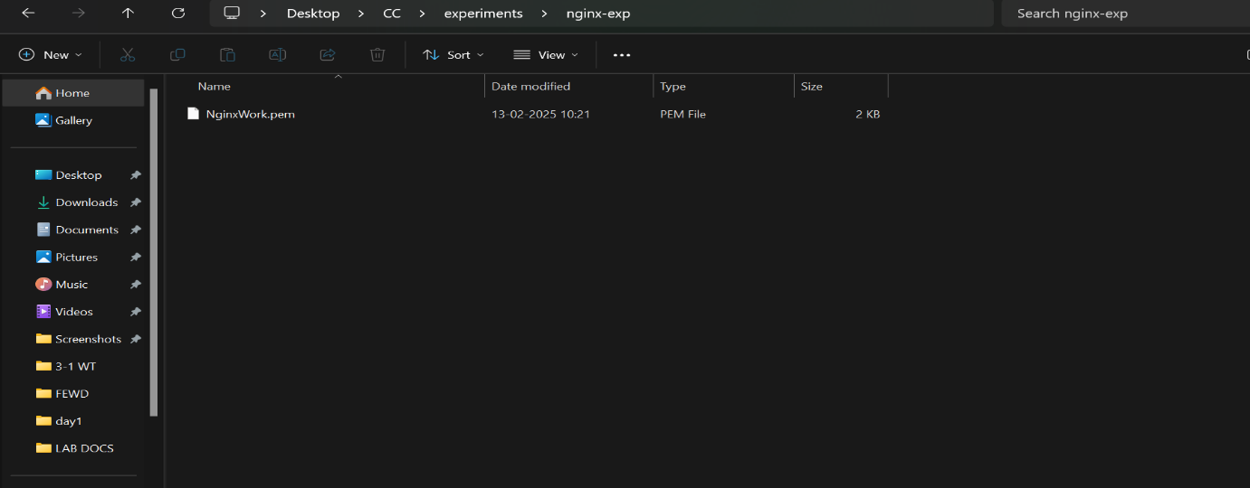

Now move to the current directory

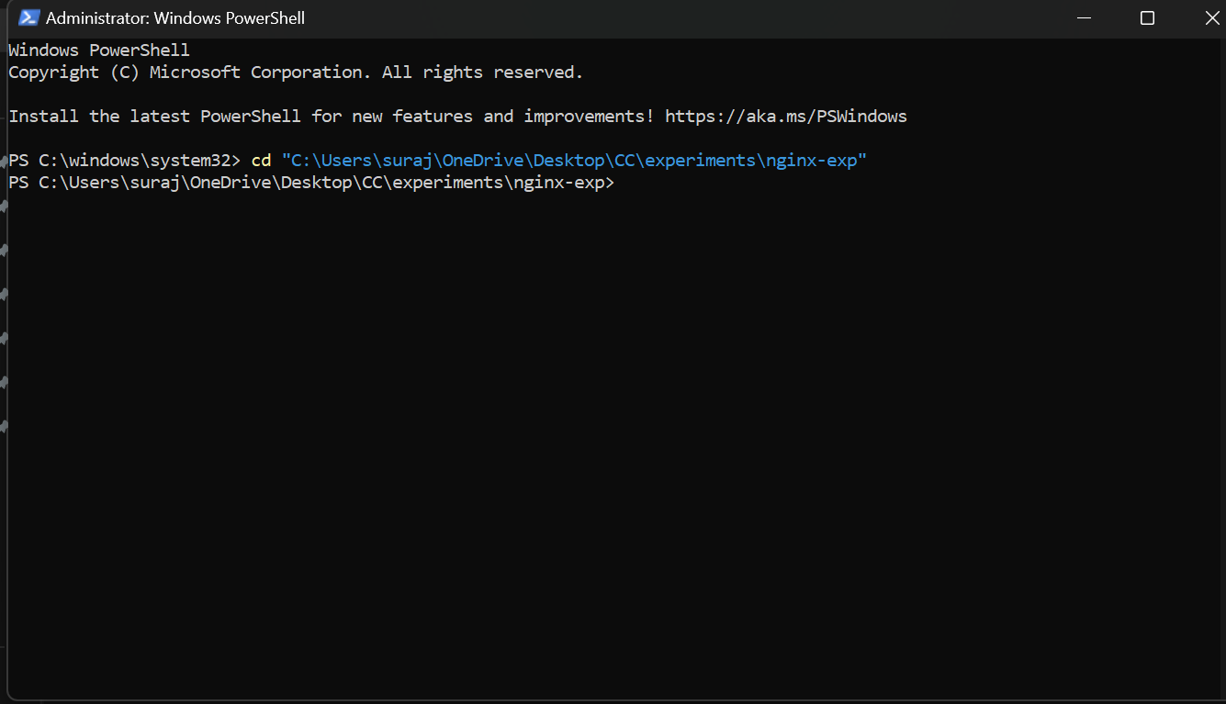

Connect to the instance using the command copied.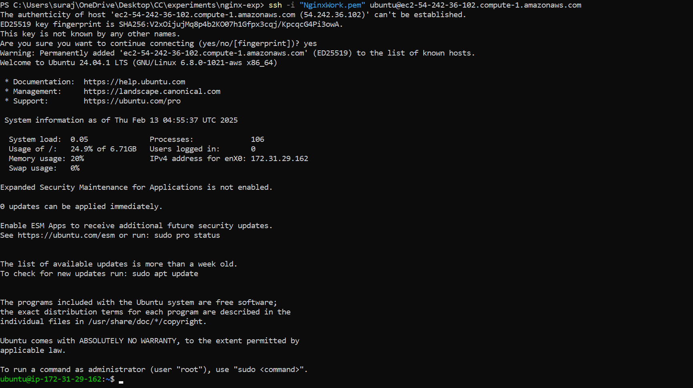

Update the instance.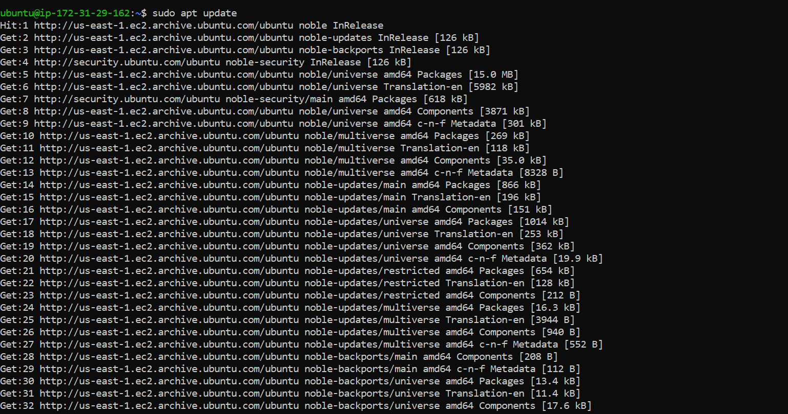

Now install docker 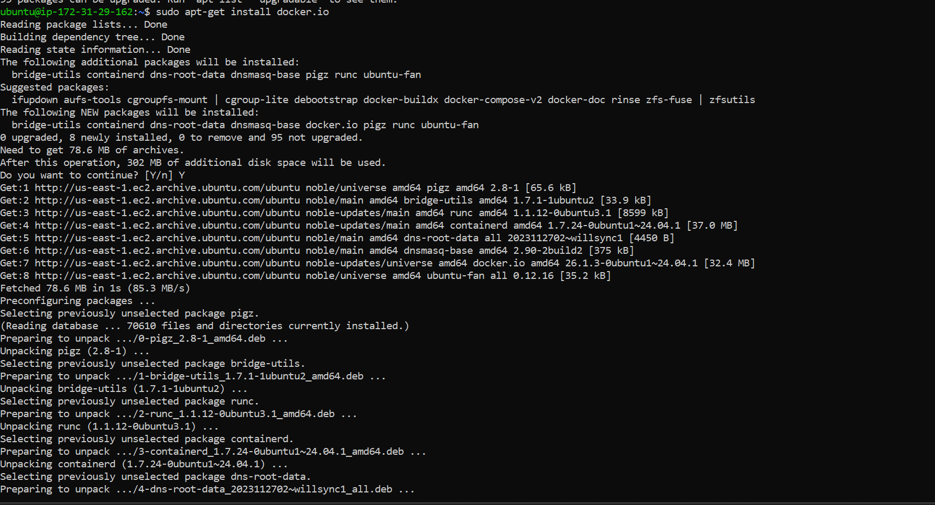

Pull the nginx image 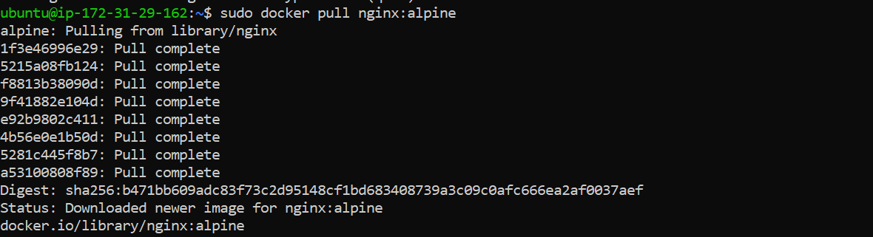

Now run the image and access it using public IPv4 of your instance

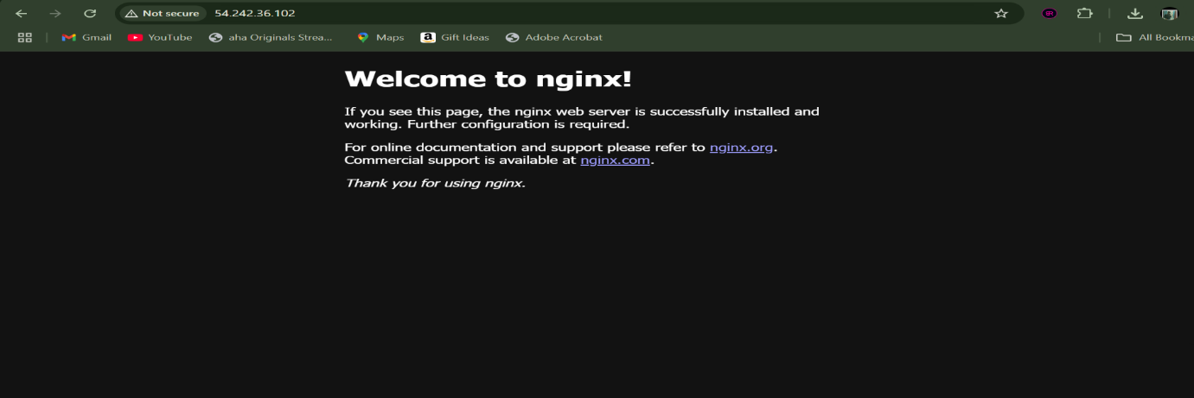

Now switch to interactive mode and navigate to html folder and create an index.html

Change the content of the html page according to use-case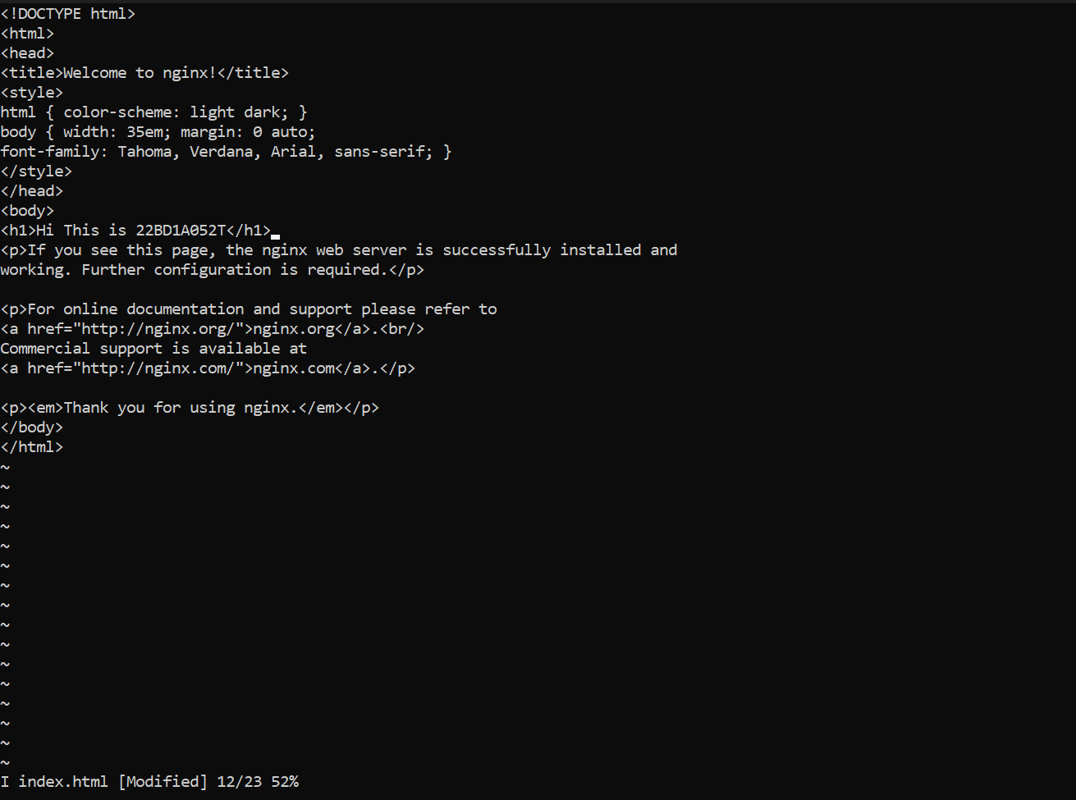

Exit from interactive mode.



Now this is our updated nginx application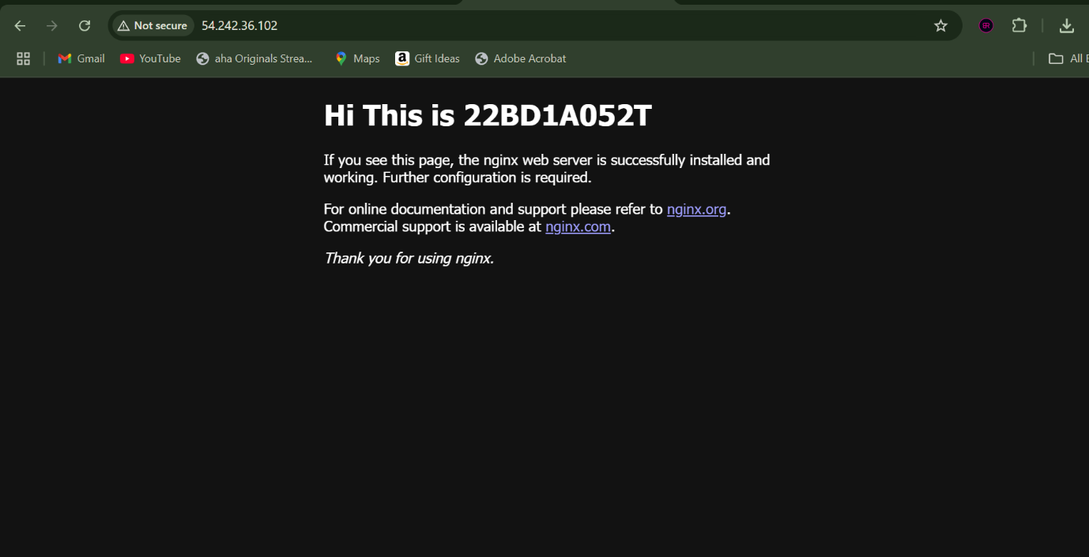

Stop and remove the container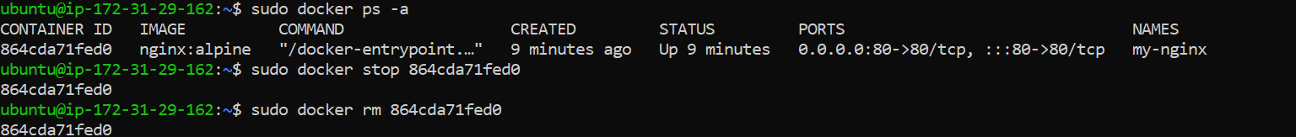

Remove the image which was pulled.  
